To host a Windows instance and use Remote Desktop Protocol (RDP) to connect, you can follow these general steps:

1. Choose a Hosting Platform

You need a cloud service provider to host your Windows instance. Popular options include:

- *Amazon Web Services (AWS)*

- *Microsoft Azure*

- *Google Cloud Platform (GCP)*

- *DigitalOcean*

2. Launch a Windows Instance

*For AWS:*

1. *Sign in to AWS Management Console*.

2. *Navigate to the EC2 Dashboard*.

3. *Click "Launch Instance"*.

4. *Choose an Amazon Machine Image (AMI)*: Select a Windows Server AMI.

5. *Choose an Instance Type*: Select the instance type based on your requirements.

6. *Configure Instance Details*: Set up instance details like network settings, subnets, and more.

7. *Add Storage*: Set the required storage.

8. *Add Tags (Optional)*: Add tags for easy management.

9. *Configure Security Group*: Create a security group that allows RDP (port 3389).

10. *Review and Launch*: Review the settings and launch the instance.

11. *Download Key Pair*: Download the key pair file (.pem) for accessing the instance.

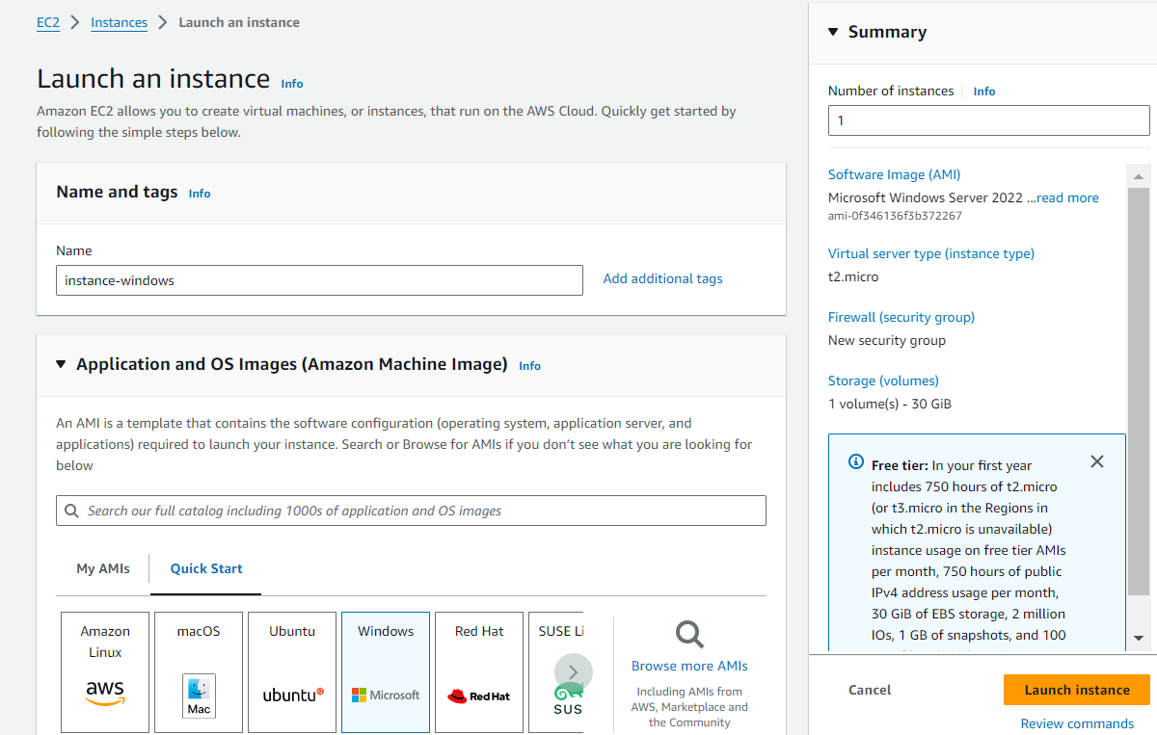

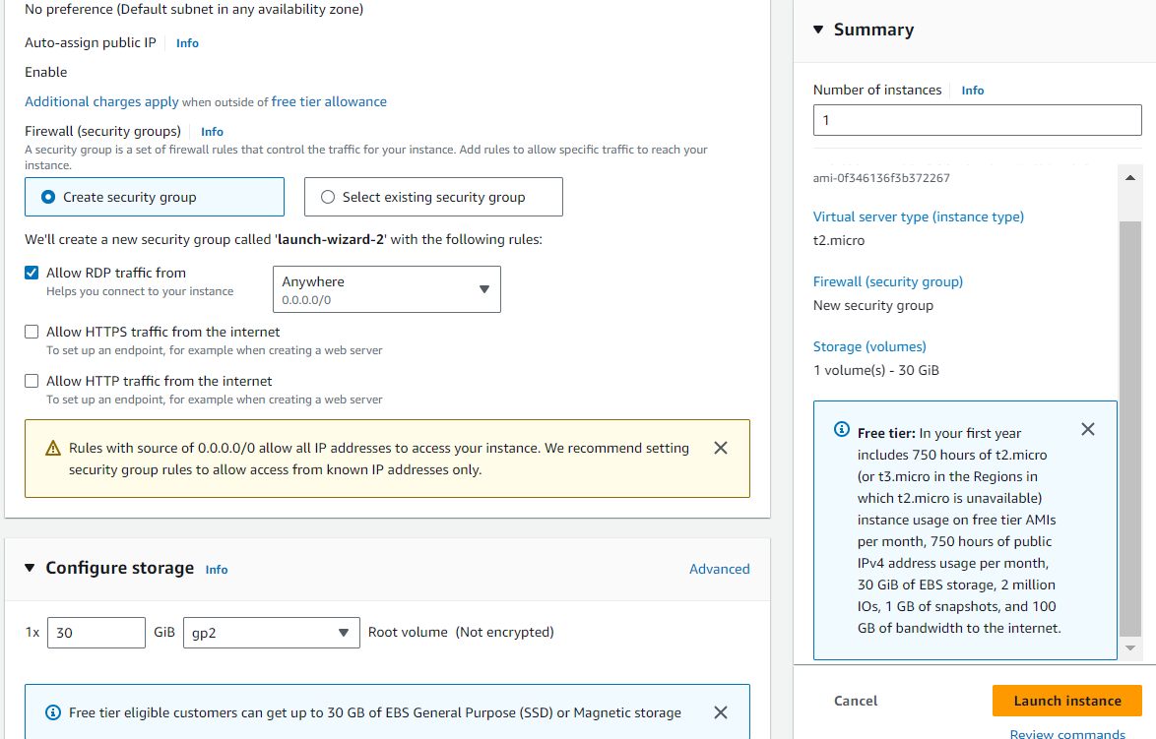

### 3. Connect to Your Windows Instance using RDP

*For AWS:*

1. *Get the Public DNS Name or IP Address* from the instance details.

2. *Decrypt the Administrator Password* using the key pair.

3. *Open Remote Desktop Connection* on your local machine.

4. *Enter the Public DNS or IP Address*.

5. *Enter the Administrator Credentials* obtained earlier.

6. *Connect*.

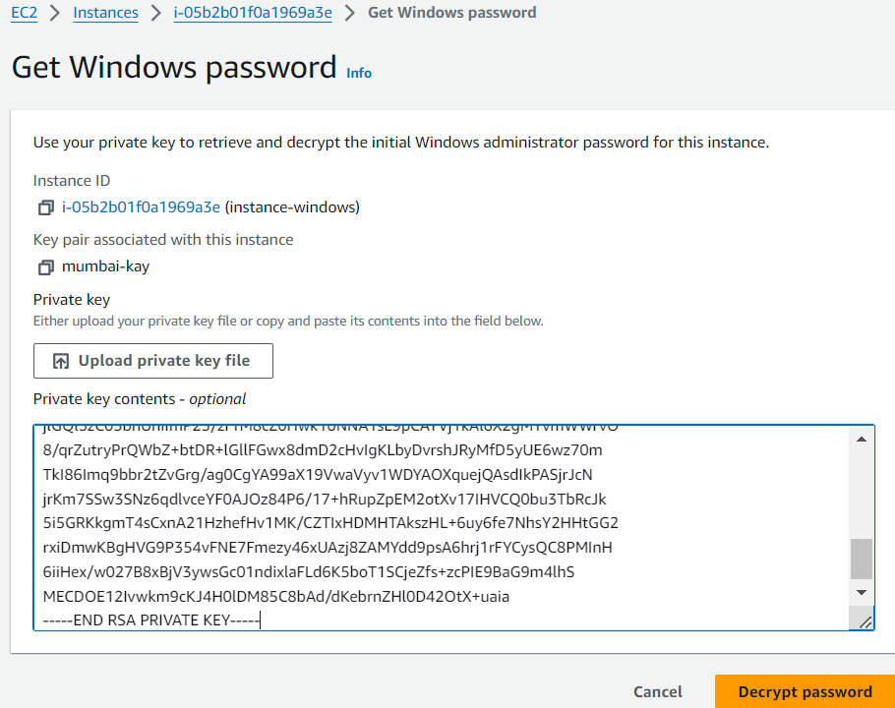

Following these steps will allow you to host a Windows instance on a cloud platform and connect to it using RDP.